PRACTICAL NO- 3
AIM- To demonstrate Skewness and Kurtosis analysis of a dataset using Python.
BRIEFING OF THE AIM
Skewness and kurtosis are two important statistical measures that describe the shape of a dataset’s distribution — beyond its central tendency and spread.
- Skewness:
Skewness measures the asymmetry of a distribution.
  - If the distribution is symmetrical, skewness = 0.
  - If it is positively skewed (right-skewed), the tail is longer on the right — meaning a few unusually high values pull the mean above the median.
  - If it is negatively skewed (left-skewed), the tail is longer on the left — meaning a few low values pull the mean below the median.
In Python, we can use scipy.stats.skew() or the pandas.skew() method to calculate it.
- Kurtosis:
Kurtosis measures the peakedness or flatness of a distribution relative to the normal distribution.
  - A normal distribution has kurtosis = 3 (excess kurtosis = 0).
  - Leptokurtic (>3) distributions are more peaked — heavy tails and more outliers.
  - Platykurtic (<3) distributions are flatter — lighter tails and fewer outliers.
We can compute kurtosis using scipy.stats.kurtosis() or pandas .kurt().

LIBRARIES USED:
- NumPy: For array handling and mathematical operations.
- Pandas: For structured data manipulation and easy statistical computation.
- SciPy: For advanced statistical analysis.
INDIVIDUAL SERIES
CODE:
import numpy as np
import pandas as pd
from scipy.stats import skew, kurtosis

# Individual series data
data = np.array([2, 3, 4, 5, 6, 7, 8, 9, 10])

print(f"Individual Series Data: {data}")
print("----------------------------------")

# Calculate skewness and kurtosis
skewness = skew(data)
kurt = kurtosis(data)

print(f"Skewness: {skewness:.4f}")
print(f"Kurtosis (Excess): {kurt:.4f}")
OUTPUT: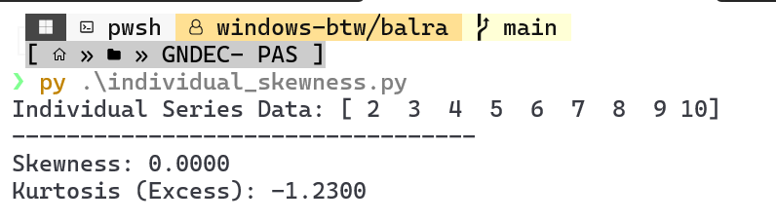
DISCRETE SERIES
CODE:
import numpy as np
import pandas as pd
from scipy.stats import skew, kurtosis

# Discrete data (x) with frequencies (f)
x = np.array([2, 3, 4, 5, 6])
f = np.array([2, 4, 5, 3, 1])

# Expand data according to frequencies
data = np.repeat(x, f)

print(f"Discrete Series Data (x): {x}")
print(f"Frequencies (f): {f}")
print("----------------------------------")

# Calculate skewness and kurtosis
skewness = skew(data)
kurt = kurtosis(data)

print(f"Skewness: {skewness:.4f}")
print(f"Kurtosis (Excess): {kurt:.4f}")

OUTPUT:
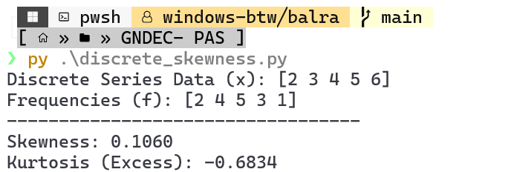
CONTINUOUS SERIES
CODE:
import numpy as np
from scipy.stats import skew, kurtosis

# Class intervals and frequencies
intervals = [(0,10), (10,20), (20,30), (30,40), (40,50)]
frequency = np.array([5, 15, 25, 8, 7])

# Calculate midpoints
midpoints = np.array([(low + high) / 2 for low, high in intervals])
data = np.repeat(midpoints, frequency)

print(f"Intervals: {intervals}")
print(f"Frequencies: {frequency}")
print("----------------------------------")

# Calculate skewness and kurtosis
skewness = skew(data)
kurt = kurtosis(data)

print(f"Skewness: {skewness:.4f}")
print(f"Kurtosis (Excess): {kurt:.4f}")

OUTPUT:
